Type the Title of the Editorial, Capitalize First Letter
First Author ª (), Second Author ^{b}, Third Author ^{a,c}
ª First affiliation, Address, City and Postcode, Country
http://yourorganization.web.page
^{b} Second affiliation, Address, City and Postcode, Country
http://yourorganization2.web.page
^{c} Third affiliation, Address, City and Postcode, Country
http://yourorganization2.web.page

ARTICLE INFO:  Received: 09 Oct 20xx  Revised: 10 Nov 20xx  Accepted: 30 Nov 20xx  Online: 12 Dec 20xx  K E Y W O R D S:  4-6 keywords  Each keyword to start on a new line. See also http://www.biomed-data.eu/content/choose-keywords |  | A B S T R A C T  Objectives, existing policy addressed, key policy recommendations; no more than 200 words.  Creative Commons BY-NC-SA 4.0  © 2016 Hosting by Procon Ltd. All rights reserved.

1. Main Text
Here introduce the paper, and put a nomenclature if necessary, in a box with the same font size as the rest of the paper. The paragraphs continue from here and are only separated by headings, subheadings, images, tables and formulae. Further instructions for authors follow below.

Spelling
Authors from the United States are welcome to use U.S. spelling. All other authors, please use consistently U.K. spelling.
For referenced sources, use the title as given in the original publication.

1.1 Structure
Files must be in MS Word only and should be formatted for direct printing, using the MS Word template provided. Figures and tables should be embedded and not supplied separately.
Please make sure that you use as much as possible normal fonts in your documents. Special fonts, such as fonts used in the Far East (Japanese, Chinese, Korean, etc.) may cause problems during processing. To avoid unnecessary errors you are strongly advised to use the ‘spellchecker’ function of MS Word. Follow this order when typing manuscripts: Title, Authors, Affiliations, Abstract, Keywords, Main text (including figures and tables), Acknowledgements, References, Appendix.
Collate acknowledgements in a separate section at the end of the article and do not include them on the title page, as a footnote to the title or otherwise.
Bulleted lists may be included and should look like this:
- First point
- Second point
- And so on
- Last bullet point.
Please do not alter the formatting and style layouts which have been set up in this template document. As indicated in the template, papers should be prepared in double column format suitable for direct printing.
Page numbers will be added by the publisher.

1.2. Tables
All tables should be numbered with Arabic numerals. Every table should have a caption. Headings should be placed above tables, left justified. Only horizontal lines should be used within a table, to distinguish the column headings from the body of the table, and immediately above and below the table. Tables must be embedded into the text and not supplied separately. Below is an example which the authors may find useful.
If the table is too large to fit within the column, create a new section by inserting two continuous section breaks and select one-column layout for this section.

Table 1. An example of a table.
An example of a column heading | Column A (t) | Column B (t)
And an entry | 1 | 2
And another entry | 3 | 4
And another entry | 5 | 6

1.3. Charts, figures, photos
All figures should be numbered with Arabic numerals (1,2,3,….). Every figure should have a caption. All photographs, schemas, graphs and diagrams are to be referred to as figures. Line drawings should be good quality scans or true electronic output. Low-quality scans are not acceptable. Figures must be embedded into the text and not supplied separately. In MS word input the figures must be properly coded. Lettering and symbols should be clearly defined either in the caption or in a legend provided as part of the figure. Figures should be placed at the top or bottom of a page wherever possible, as close as possible to the first reference to them in the paper.
The figure number and caption should be typed below the illustration in 10 pts and left justified [Note: C entre one-line captions of length less than column width centred]. Artwork has no text along the side of it in the main body of the text.

Figure 1: Sample illustration.
If a chart or an image is too large to fit within the column, create a new section by inserting two continuous section breaks and select one-column layout for this new section. See the example below.

1.4. Construction of references
Use endnotes to cite a source in the text. Thus, references are numbered consecutively in the list at the end of the article in the order they are cited in the text. Use font size 10 pts and single-spaced paragraphs.
Use one endnote for each referenced source. If you want to cite more than one source in support of your point, separate endnote marks by a coma.,
If you need to cite more than two sources, then insert the notes, e.g. 8, 9, 10, 11, 12, as usual but without the commas. Then insert an en dash ( – ) after the 8 or before the 12. Then select 9 10 11 and press Ctrl+Shift+H to format the reference numbers as Hidden. As a result you will have ⁸⁻¹¹ as reference to the five sources.
If you are on a Mac or the keyboard shortcut does not work, use Format>Font to format the reference numbers as Hidden.

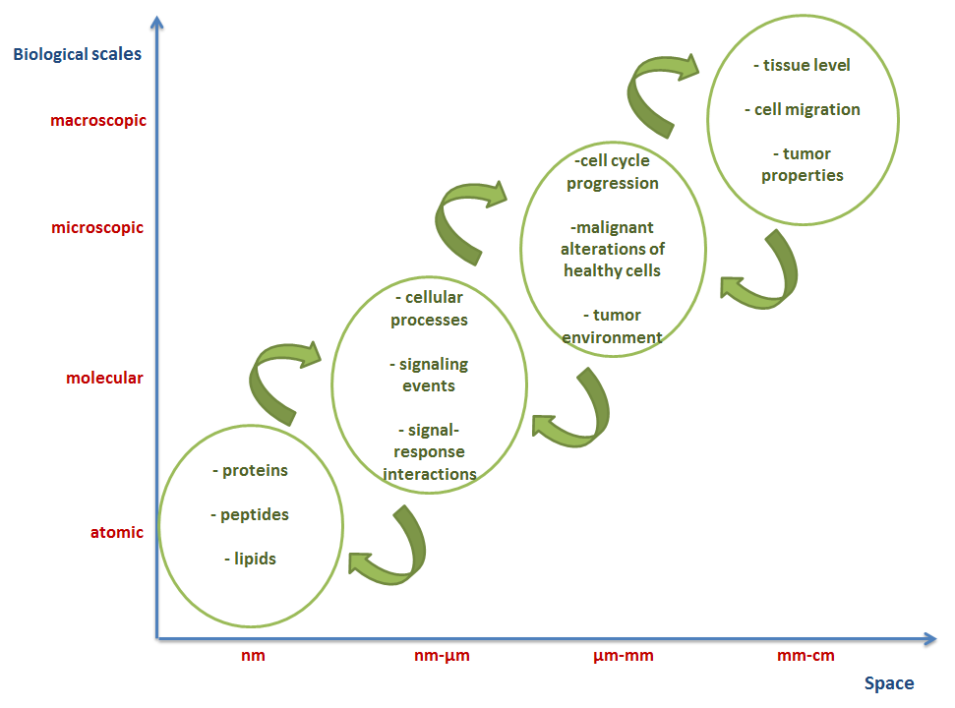
Figure 2: Illustration of the biological scales for computational cancer models including atomic, molecular, microscopic and macroscopic.
If you need to refer to a source more than once, do not insert it again as an endnote, but use instead Insert > Cross-reference and select Reference type “Endnote” and then the respective endnote.
For the referenced sources BMDJ applies the Style Guide of the US National Library of Medicine (NLM). Please consult the NLM Style Guide, www.nlm.nih.gov/citingmedicine. A short guide on the main types of references is available at http://www.biomed-data.eu/content/style.
At the end include the DOI number of the cited source, include its DOI number. If a DOI is not available, include its PubMed Identifier (PMID).
Most papers in the biomedical field will have at least one of these identifiers assigned. If you wish to cite a paper, a book, a report or an official document that does not have a DOI or PMID assigned, please include the most recent working URL to the source.

1.5. References to datasets
Data citations provide bibliographic information for the data records described in the manuscript. These should be in the format “Lastname1 Initial(s)1, Lastname2 Initial(s)2, Lastname3 Initial(s)3. Repository_name Dataset_accession_number or DOI (Year).”
In the text of the paper refer to a dataset placing its number in parentheses (Data Citation 1). You can use either the dataset accession number or its DOI (Data Citation 2).

1.6. Section headings
Section headings should be left justified, bold, with the first letter capitalized and numbered consecutively, starting with the Introduction. Sub-section headings should be in capital and lower-case italic letters, numbered 1.1, 1.2, etc., and left justified, with second and subsequent lines indented. All headings should have a minimum of three text lines after them before a page or column break. Ensure the text area is not blank except for the last page.

1.7. General guidelines for the preparation of your text
Symbols denoting vectors and matrices should be indicated in bold type. Scalar variable names should normally be expressed using italics. Weights and measures should be expressed in SI units. All non-standard abbreviations or symbols must be defined when first mentioned, or a glossary provided.

1.8. Footnotes
Footnotes should be avoided if possible. Necessary footnotes should be denoted in the text by consecutive superscript roman numbers.^{ii} The footnotes should be typed single spaced, and in smaller type size (10 pt), at the foot of the page in which they are mentioned, and separated from the main text by a one line space extending at the foot of the column.
Please do not change the margins of the template as this can result in the footnote falling outside printing range.

2. License
Authors who publish with BMDJ will retain all intellectual property rights, including moral rights in their work. Data papers/metadata accompanying the research data, including the abstract describing the research data, will be licensed to the public under “Creative Commons 4.0 Attribution-NonCommercial-ShareAlike” International license (CC BY-NC-SA 4.0).

3. Conclusions
Once ready with the text, please hyphenate it using the feature incorporated in Word for Windows. Select ‘Manual’ hyphenation and do not hyphenate titles, URL addresses and the like. Avoid also hyphenation at the end of a line.
Once accepted and ready for online publication, the publisher will insert page numbers and assign a DOI to your paper.

Acknowledgements
Acknowledgements and Reference heading should be left justified, bold, with the first letter capitalized but have no numbers. Text below continues as normal.

Appendix A. An example appendix
Authors including an appendix section should do so before References section. Multiple appendices should all have headings in the style used above. Please order them as Appendix A, B, C etc.

A.1. Example of a sub-heading within an appendix
There is also the option to include a subheading within the Appendix if you wish.

A.2. Example of a sub-heading within an appendix
Number sub-headings consecutively.

Data Citations
¹ Finlayson SG, LePendu P, Shah NH. Dryad http://dx.doi.org/10.5061/dryad.jp917 (2014).
² Baric R, Katze M, Chang J, Gralinski L, Law L. Gene Expression Omnibus GSE37569 (2012).

References

Lindert S, Li MX, Sykes BD, McCammon JA. Computer-Aided Drug Discovery Approach Finds Calcium Sensitizer of Cardiac Troponin. Chem Biol Drug Des. 2014 Jun 20. DOI: 10.1111/cbdd.12381.
Silva, L. PLOS’ New Data Policy: Public Access to Data. 24 February 2014. Available at www.plos.org/ plos-data-policy-faq.
Zhang P, Brusic V. Mathematical modeling for novel cancer drug discovery and development. Expert Opin Drug Discov. 2014 Jul 25: 1-18. DOI: 10.1517/174604 41.2014.941351.
Lawrence B, Jones C, Matthews B, et al. Citation and peer review of data: Moving towards formal data publication. Int J Digital Curation. 2011;6(2):4–37. DOI: 10.2218/ijdc.v6i2.205.
Kourou K, Fotiadis DI. Computational Modelling in Cancer: Methods and Applications. Biomed Data J. 2015;1(1):15-25. DOI: 10.11610/bmdj.01103.
Pantos C, Schroeder M, Ivanova P. Open Access to Quality Biomedical Experimental and Clinical Data and Data-based Models. Biomed Data J. 2015;1(1):01-02. DOI: 10.11610/bmdj.01101.
Guedj D, Ramjoué C. European Commission Policy on Open-Access to Scientific Publications and Research Data in Horizon 2020. Biomed Data J. 2015;1(1):11-14. DOI: 10.11610/bmdj.01102.
HORIZON 2020 Work programme 2014-2015, Health, demographic change and wellbeing. PHC2-Understanding diseases: systems medicine. Available from: http://ec.europa.eu/research/participants/data/ ref/h2020/wp/2014_2015/main/h2020-wp1415-health_en.pdf.

